Ideation Phase
Brainstorm & Idea Prioritization

Date | 25 November 2025
Team ID
Project Name | BookStore
Maximum Marks | 4 Marks

Step-1: Team Gathering, Collaboration and Select the Problem Statement
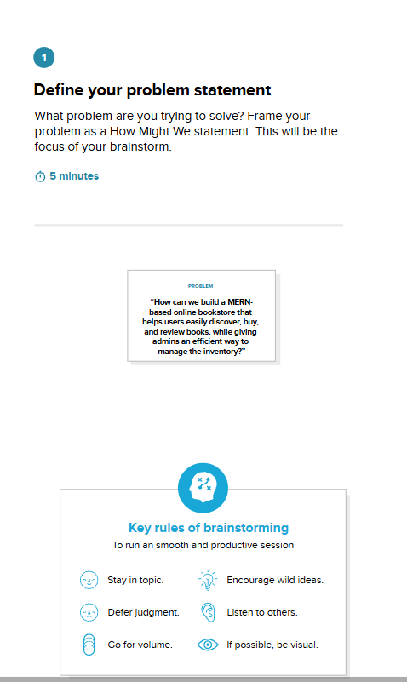

STEP 2: Brainstorm, Idea Listing and Grouping
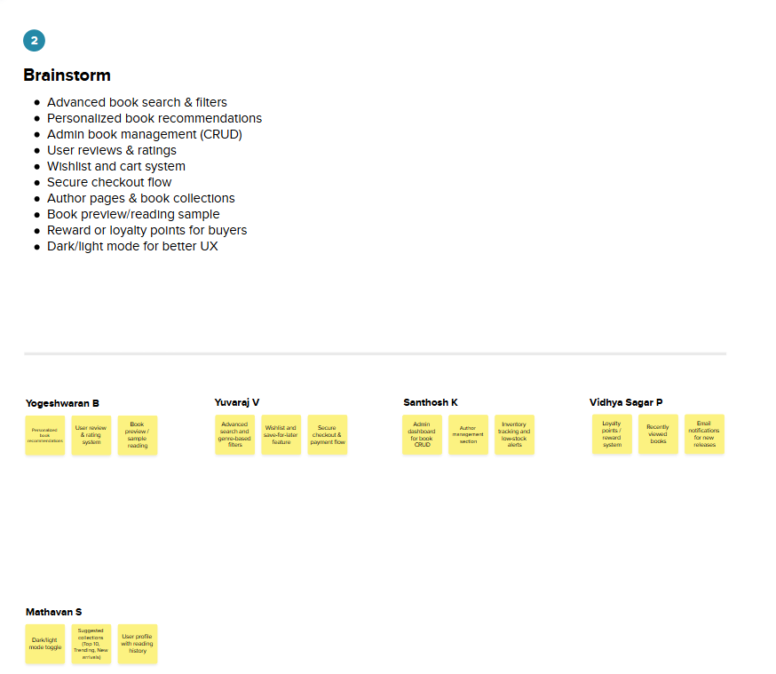
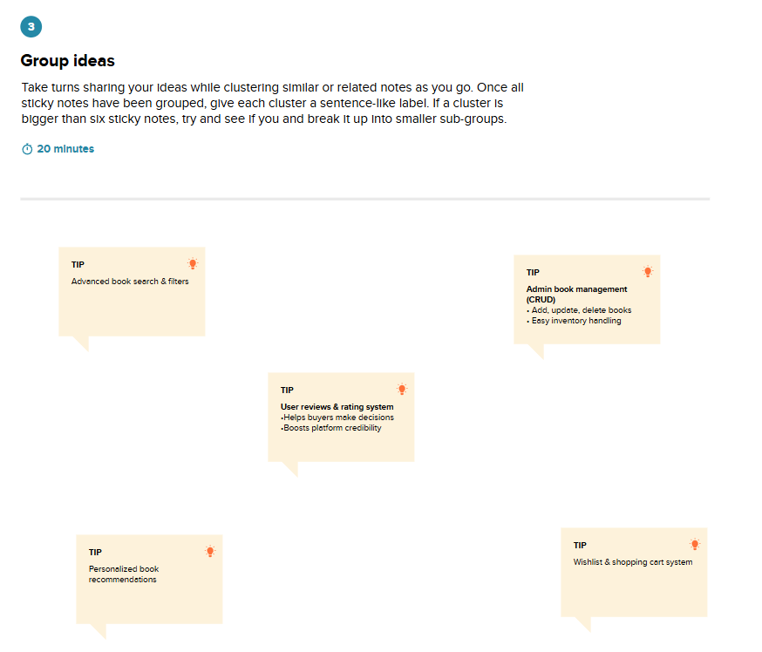

STEP 3: Idea Prioritization
